User Manual

This program follows a simple user input system through a combination of integers and doubles. Words and sentences are expressed without spaces and therefore can either be padded with underscores or left out entirely.

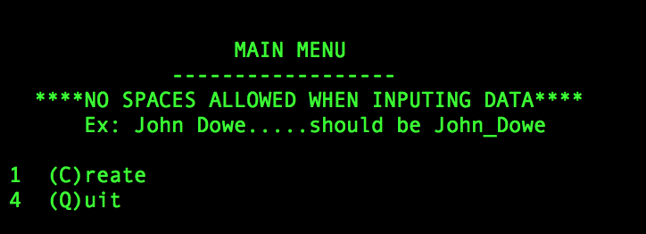

This is the first bit of content that you as the user will be confronted with. It gives the basic rules of the program that I have laid out previously and then starts you off with the main menu from which the user can make a choice to create or quit.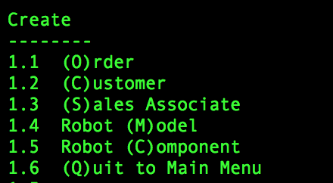

If a 1 was entered by the user then the create tab will open up and list another variety of options that the user can then pick from. An order command may only be given once the boss (you) has created a Salesman, Customer, and Robot model. A robot model is created by creating multiple robot components and then stitching them together into a single model. Once this Model is created along with a salesman and a customer, an order can then be placed for said model. A few examples of the variety in options are given below.

